1. Read trial1.xlsx file using readtable, define variables , and plot 3d trajectories of the markers.

%% importing data and stuff

data1 = readtable("Trial1.xlsx");

data1(1:7,:)=[]; % make top 7 rows empty

data1(:,12:14)=[]; % make last few columns empty

data1array = table2array(data1);

Frame = data1(:,1);

Frame = table2array(Frame);

Time=data1array(:,2);

X1=data1array(:,3);

Y1=data1array(:,4);

Z1=data1array(:,5);

X2=data1array(:,6);

Y2=data1array(:,7);

Z2=data1array(:,8);

X3=data1array(:,9);

Y3=data1array(:,10);

Z3=data1array(:,11);

plot3(X1,Y1,Z1); hold on;

plot3(X2,Y2,Z2);

plot3(X3,Y3,Z3);

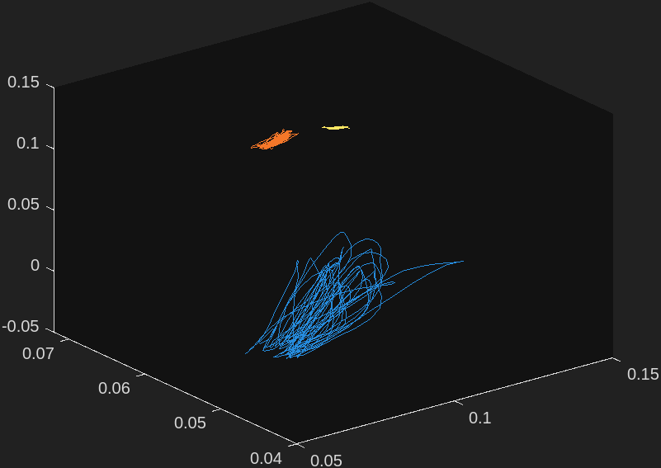

1. Create a stick figure of the arm. Connect the shoulder, elbow and hand with a line at Time=0 (Fig.1).

line([X1(1),X2(1),X3(1)],[Y1(1),Y2(1),Y3(1)],[Z1(1),Z2(1),Z3(1)]);hold off;

view([36.6 8.4]);

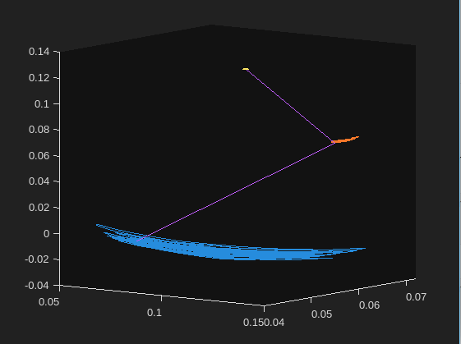

1. Plot X, Y and Z coordinates of the hand marker over time (Fig.2).

%figure 2

figure;

subplot(3,1,1);

plot(Time, X1);

ylabel("hand X position")

xlabel("Time")

subplot(3,1,2);

plot(Time, Y1);

ylabel("hand Y position")

xlabel("Time")

subplot(3,1,3);

plot(Time, Z1);

xlabel("Time")

ylabel("hand Z position")

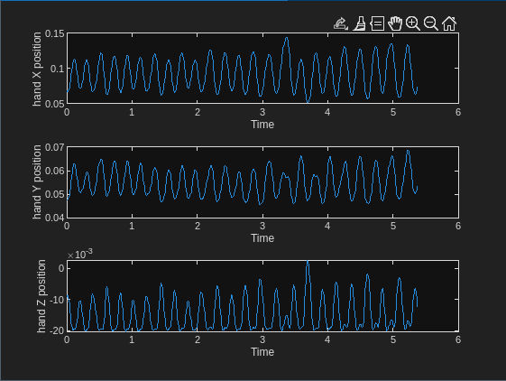

1. Calculate hand velocity along the X axis and plot it versus time (Fig.3).

% diff

% figure 3

figure

dX1 = diff(X1);

dTime = diff(Time);

xvel = dX1./dTime;

xvel = [xvel; xvel(end)];

subplot(2,1,1)

plot(Time,xvel)

hold on;

xlabel("Time")

ylabel("X Velocity")

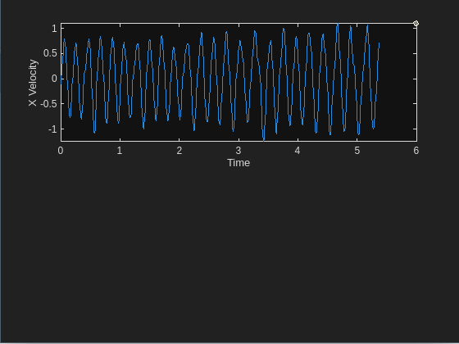

1. Use findpeaks function to identify all peaks in the velocity trace and plot these peak values on top of the velocity trace. Add the hand X coordinate plot over time to Figure 3.

% finding peakkkkkk

[peakX, locX] = findpeaks(xvel, Time);

scatter(locX,peakX);

subplot(2,1,2)

plot(Time,X1)

ylabel("X position")

xlabel("Time")

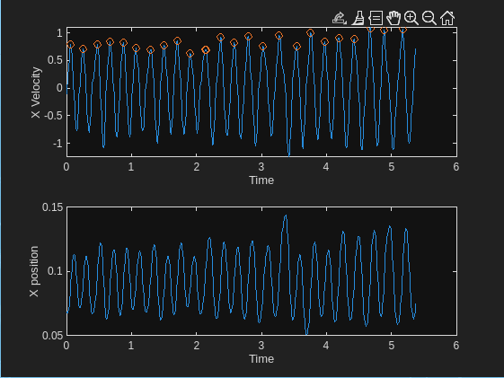

1. Plot a phase diagram of hand motion (velocity versus position) along the X axis (Fig.4)

% finding the phase diagram

figure

plot(X1,xvel);

hold on;

y=[0,0];

x=[0.05,0.15];

plot(x,y)

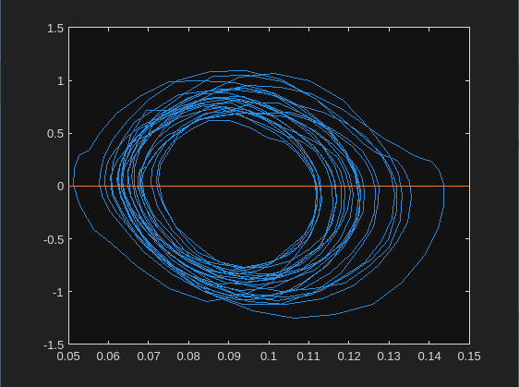

1. Calculate the distance between shoulder and hand markers, and plot it over time. You might consider calculating this distance at time zero first (Fig.5). Use two different methods (using the norm function or the standard coordinate-based formula) and compare the outcomes.

% distance between shoulder hand using coords figure 5

figure

shX = X3-X1;

shY = Y3-Y1;

shZ = Z3-Z1;

shXsquared = shX.^2;

shYsquared = shY.^2;

shZsquared = shZ.^2;

sumcoords = sqrt(shXsquared + shYsquared + shZsquared);

plot(Time,sumcoords)

% distance between shoulder hand using norm

dist = [shX, shY, shZ];

d = size(dist);

n = zeros(d(1),1);

for i = 1:d(1)

n(i,1) = norm(dist(i,:),2);

end

figure

plot(Time,n)

title('Distance vs Time')

xlabel('Time (sec)')

ylabel('Distance from hand to shoulder')

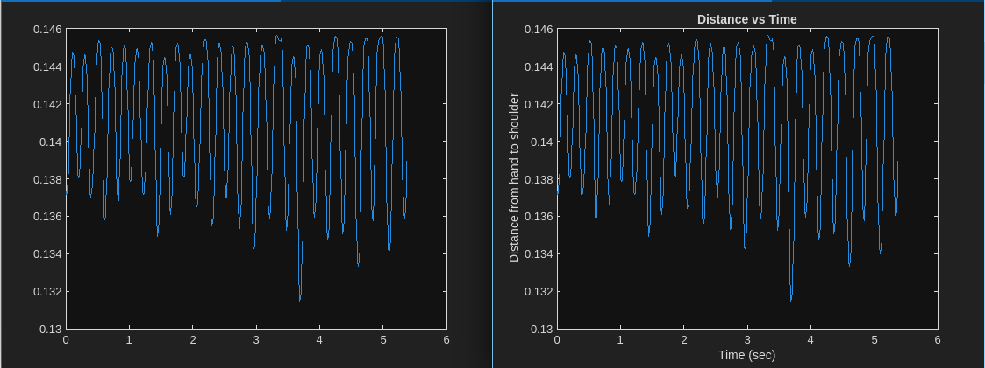

1. Calculate the elbow angle using the dot function and plot it over time. You might consider calculating this distance at time zero first. (Fig.6)

% angle over time

% Number of data points

numPoints = length(Frame);

% Initialize angles array

angles = zeros(numPoints, 1);

% angles

for i = 1:numPoints

% Shoulder to Elbow (stoe) and Elbow to Hand (etoh)

stoe = [X3(i) - X2(i), Y3(i) - Y2(i), Z3(i) - Z2(i)];

etoh = [X2(i) - X1(i), Y2(i) - Y1(i), Z2(i) - Z1(i)];

% Dot product

dotProduct = dot(stoe, etoh) / (norm(stoe) \* norm(etoh));

dotProduct = max(min(dotProduct, 1), -1);

angles(i) = rad2deg(acos(dotProduct));

end

% Plotting

plot(Time, angles);

xlabel('Time');

ylabel('Elbow Angle (degrees)');

title('Elbow Angle Over Time');

